S2991

ON AN ASSURED SHORTHOLD TENANCY FOR 6/12 MONTHS INITIALLY

14 QUAKER LANE, NORTHALLERTON DL6 1EQ
Address
• A Well Presented 3 Bedroomed Family House
• Refurbished Large Light Airy Rooms
• Much Sought After & Convenient Location

Rent: £535 Per Calendar Month

Subject to Bond and References

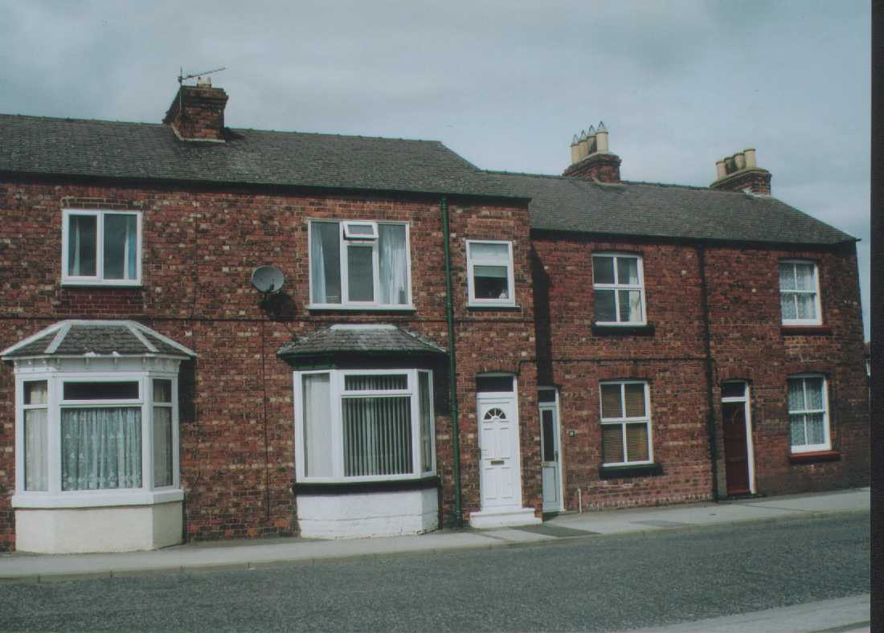

AN IMMACULATELY PRESENTED 3-BEDROOM TERRACE HOUSE, CONVENIENTLY SITUATED FOR NORTHALLERTON TOWN CENTRE

• Partially Furnished
• Available for Occupation in mid August
• No DSS, No Smokers and No Pets

SITUATION

Darlington 16 miles Bedale 9 miles
A.1 8 miles Thirsk 7 ½ miles
A.19 7 miles Teesside 16 miles
York 30 miles
(All distances are approximate)

14 Quaker Lane is pleasantly situated on the edge of the very popular and much sought after market town of Northallerton the County Town of North Yorkshire.

The property enjoys a very pleasant position adjacent to Quaker Lane. The property lies within convenient and easy commuting distance of Bedale, the A.1, A.19 trunk roads, Teesside, York, Darlington, Thirsk and all surrounding towns and villages.

The town of Northallerton enjoys a full and comprehensive range of educational, recreational and medical facilities.

This area of North Yorkshire is ideally placed for commuting with an East Coast main line train station at Northallerton linking London to Edinburgh and bringing London within 2 ½ hours commuting time. Additionally via the Transpennine route that calls at this station there is direct access to Newcastle, Middlesbrough, Darlington, Leeds, York, Manchester, Liverpool and Manchester Airport.

The A.1 and A.19 trunk roads are both within easy reach of the property and offer excellent communications and access onto the main arterial road networks of the UK.

International Airports can be found at Teesside (30 minutes), Leeds/Bradford, Newcastle and Manchester.

This area of North Yorkshire lies between the North Yorkshire Dales and the North Yorkshire Moors National Park where much renowned walking, riding and leisure activities can be found. Additionally the property is within an hour of the Coast at Scarborough, Whitby and Redcar, which offers further opportunities of varied and interesting leisure activities. In and around the town of Northallerton there is additionally good walking, fishing and riding to be enjoyed.

AMENITIES

Shopping – market town shopping is available at Northallerton, Bedale, Thirsk, Darlington and Richmond.

The major centres of Teesside, Leeds, Durham and York are all readily accessible.

Hospitals – the Friarage Hospital is located approximately two miles away at Northallerton and is a renowned Hospital.

Bus Service – there is a regular bus service to Darlington calling at the villages.

Schools – the area is well served by good state and independent schools. Comprehensive schools at Northallerton, Thirsk, Bedale, Richmond and Darlington. Independent Schools at Polam Hall (Darlington), Hurworth House, Teesside High, Yarm, Ampleforth, Queen Mary’s at Baldersby and Cundall Manor.

Shooting & Fishing – the property is attractively positioned in an area renowned for its quality shoots and good fishing being within easy reach of the North Yorkshire Moors and North Yorkshire Dales and close to local rivers and ponds.

Racing – Catterick, Ripon, Thirsk, York, Sedgefield, Beverley, Doncaster and Newcastle

Golf – Romanby (Northallerton), Bedale, Thirsk, Darlington, Richmond and Catterick.

Walking & Cycling – the area is well served for attractive cycling and walking with some particularly attractive countryside and scenery around the property.

Leisure Centres – Northallerton, Bedale, Richmond and Darlington

DESCRIPTION

The property comprises a substantial, well laid out, spacious and very attractively presented and appointed 3-bedroomed family house and is situated in a quiet position on the edge of the much sought after town of Northallerton. It is ideally situated within easy reach of all local amenities, services etc. and is close to attractive countryside and enjoys excellent commuting to all of the major centres.

Internally the property has been largely refurbished and is well laid out providing spacious family accommodation.

On the ground floor the property enjoys a spacious Entrance Hall leading to the property’s anti-clockwise turning staircase. The South facing bay window in the Lounge creates a light and airy feel. The Lounge is also particularly well appointed offering polished wood floors, attractive fireplace and an ornate picture rail. The Breakfast Kitchen has a generous range of base and wall mounted units. A useful Hallway leads through to the property’s newly appointed, fully tiled Bathroom.

On the First Floor you are welcomed by a large landing area, leading to two Double Bedrooms together with a useful Single Bedroom/Dressing room

The property enjoys the benefit of full gas fired central heating and has UPVC double glazed windows and doors throughout.
The offering of 14 Quaker Lane presents a rare opportunity to rent a substantial well constructed, well presented 3-bedroomed family house in a good residential area, which enjoys excellent access to local and national transport links.

ACCOMMODATION

Living Room
3.99m x 3.91m (13’1” x 12’10”) max

South facing bay window. Picture rail. Coved corniced ceiling. Ornate ceiling feature. Double radiator. Gas fire set within a wooden fireplace with tiled surround and hearth. Polished wood floor. With telephone connection

Kitchen
4.04m x 3.63m (13’3” x 11’11”) max

Generous range of base and wall mounted units including breakfast bar, single sink drainer, tiled splashback, chimney breast housing gas boiler. Coved corniced ceiling. Tiled floor and door to understairs cupboard complete with fitted shelves. Tiled floor.

Rear Hall
2.26m x 1.83m (7’5” x 6’) max

Space and plumbing for washing machine. Fitted shelves providing useful storage space. Door to rear yard.

Bathroom
2.38m x 2.08m (7’10” x 6’10”) max

West facing window. White Ideal Standard bathroom suite comprising WC, pedestal wash hand basin and bath. Double radiator with Stainless Steel towel rail above. Fully tiled walls and floor. Bath complete with Mira shower over. Extractor fan.

FIRST FLOOR
Landing
3.74m x 1.65m (12’3” x 5’5”) max

Coved corniced ceiling. Attractive panelled decoration on staircase and landing.

Bedroom No. 1
3.33m x 3.25m (10’11” x 10’8”) max

South facing window. Single radiator. Black lead fireplace within wooden fire surround.

Bedroom No. 2
3.63m x 3.25m (11’11” x 10’8”) max

Single radiator. North facing window. Cupboard housing hot water tank, fitted shelves in chimney alcove, coved corniced ceiling.

Bedroom No.3/Dressing Room
2.36m x 1.65m ( 7’9” x 5’5”)

Coved corniced ceiling. South facing window. Double radiator.

OUTSIDE

The property has the benefit of a rear yard, which can be accessed from a lane that runs behind the properties. There is a small brick built shed in the rear yard.

GENERAL REMARKS AND STIPULATIONS

RENT
£535.00 per calendar month.

SERVICES
Mains Water, Electricity and Drainage. The Tenant will be
Responsible for paying for all mains services.

COUNCIL TAX
The Tenant will be responsible for paying for the Council Tax on
the property. We are verbally informed by Hambleton District
Council that the Council Tax Band is B.

PERIOD OF LETTING
6 months initially on an Assured Shorthold Tenancy.

INSURANCE
The Landlord will insure the structure and the contents and the
Tenant will insure his/her contents.

PETS
The property is let on the condition that no animals or pets are
kept on the property without the prior consent of the
Landlord/Agent.

REFERENCES
The Letting Agents will require references. Seriously interested parties should contact the Letting Agents for a form (one form per single person), which is to be completed and returned to them, together with a cheque for £30 per form / person

AGENTS FEES
The Tenant will pay the Agents Fees on the Tenancy Agreement
and Counterpart in the sum of £180.00

BOND
The Tenant will be required to pay a Bond of £550.00. This sum
will be returnable to the Tenant when he/she vacates the
property provided that the Tenant has left the property in a clean
and tidy condition and has not caused any damage to the
property, subject to normal wear and tear and subject to all rents
being paid up to date.

VIEWING
By appointment with Northallerton Estate Agency _ Tel (01609)
771959.

14 Quaker Lane, Northallerton

Insert Map
Insert Map
Insert Map

